**G - clothing 93992, 9 seeds**

**C - person 78981, 9 seeds**

**G - home 58109, 8 seeds**

**C - vehicle 47164, 10 seeds**

**C - animal 21607, 9 seeds**

**C - structure (construction) 8717, 7 seeds**

**G - food 7693, 4? seeds**

**C - plant 795**

G - artifact 31646

G - container 21100

C - material 17522

G - device 8723

C - appliance 6731

G - tool 1396

G - toy 306 # all dolls

C - weapon 192

G - instrument 189

**Annotation procedure**

* Based on the concepts (can be viewed as “basic-level” categories) in McRae’s feature norms, plus the categorisation of these concepts provided by VISA (supercategories and subcategories) and BLESS + *persons*.
* Goal: Define a set of “seed” categories which we will use for our study.   
  Using these seeds, we will collect example images from Visual Genome.  
  Specifically, for each seed, we collect N images which depict the seed or any

category subsumed by the seed.

[“X subsumes Y” means that there is a(n in)direct path in the WordNet hierarchy

between X and Y, where X is closer to the root than Y.]

* Method: Collect the WordNet synsets (i.e., the nodes in the WordNet hypernym taxonomy according to which nouns are structured) which subsume McRae’s concepts as well as Visual Genome’s highly frequent object categories (basic or sublevel categories).  
  More specifically:
  + For each supercategory (e.g., *structures, animals, vehicles*):

(i) Add a category as seed if it fulfills the two conditions:

* + - There is a (sub/basic-level)category (e.g., in VISA or in WordNet) which subsumes at the very least 2 more specific categories in Visual Genome.
    - The latter have a frequency of more than approx. 10 (frequency = #objs with specific synset in Visual Genome).

(ii) Extract all objects from VG subsumed by the selected seeds, compute   
 statistics (# diff. object names, # images/name, #images/seed).

* + On the basis of the statistics, finalise the hierarchy.

**Comments**

*[CS]*

* *Question: Maybe we should set a threshold on the number of “collections nodes” for each category? Otherwise the size of the diff. categories may vary a lot.*
* *What to do with this huge group of artifact -> instrumentality, instrumentation -> device?*

*other hyponyms of instrumentality, instrumentation:*

*(implement ->) tool -> hand tool*

**G - clothing 93992**

· **pretty well behaved!**

**[CS could be categorised on a coarser level also]**

**[GBT marking 9 seeds]**

*(right column gives collection synsets)*

|  |  |
| --- | --- |
| artifact -> covering | footwear, footgear |
| instrumentality, instrumentation | device -> fastener, fastening, holdfast, fixing |
| clothing | accessory |
| clothing | clothing |
| clothing | **footwear.n.01** |
| clothing | handwear, hand wear -> **glove.n.02** |
| clothing | **headdress, headgear** |
| clothing | protective garment |
| clothing -> garment | garment |
| clothing -> garment | **neckwear** |
| clothing -> garment | **robe.n.01** |
| clothing -> garment | scarf.n.01 |
| clothing -> garment | **shirt.n.01** |
| clothing -> garment | undergarment, unmentionable |
| clothing -> garment -> overgarment, outer garment | **overgarment, outer garment** |
| clothing -> garment -> overgarment, outer garment | coat.n.01 |
| clothing -> woman's clothing | **dress.n.01** |

Snodgrass (1980): [sock]; trouser (pants); [coat]

**C - person 78981**

**[GBT marking 9 seeds]**

|  |  |
| --- | --- |
| person -> contestant | **athlete, jock** |
| person -> creator | **artist** |
| person | **worker** |
| person -> adult, grownup | **professional, professional person** |
| person -> adult, grownup | **adult male, man** |
| person -> adult, grownup | **adult female, woman** |
| person -> juvenile, juvenile person | **child.n.01** |
| person -> male, male person | **male child, boy** |
| person -> female, female person | **female child, girl, little girl** |

G - **home 58109**

**[GBT marking 8 seeds]**

· furniture: no real hierarchical structure. A few items have different subtypes, but mostly not very interesting ("armoire", "wardrobe").

· kitchen utensils same problem. Few decent ones, though more than furniture (3-4).

[CS If we want to include furniture: ...]

|  |  |  |
| --- | --- | --- |
|  | collection synset | maybe? |
| instrumentality, instrumentation -> device | source of illumination | **lamp.n.01** |
| instrumentality, instrumentation -> furnishing | **furnishing** | curtain.n.01 |
| instrumentality, instrumentation -> furnishing -> furniture, piece of furniture, article of furniture | **bedroom furniture** |  |
| instrumentality, instrumentation -> furnishing -> furniture, piece of furniture, article of furniture | **seat.n.02** | bench |
| instrumentality, instrumentation -> furnishing -> furniture, piece of furniture, article of furniture | seat.n.02 | chair |
| instrumentality, instrumentation -> furnishing -> furniture, piece of furniture, article of furniture | seat.n.02 | stool.n.01 |
| instrumentality, instrumentation -> furnishing -> furniture, piece of furniture, article of furniture | seat.n.02 |  |
| **instrumentality, instrumentation -> furnishing -> furniture, piece of furniture, article of furniture** | furniture, piece of furniture, article of furni  ture | table.n.02 |
| instrumentality, instrumentation -> furnishing -> furniture, piece of furniture, article of furniture | furniture, piece of furniture, article of furniture | cabinet.n.01 |
| instrumentality, instrumentation -> furnishing -> furniture, piece of furniture, article of furniture | furniture, piece of furniture, article of furniture |  |

Snodgrass (1980): desk, cabinet (dresser), television

[... or kitchen utensils:]

|  |  |  |
| --- | --- | --- |
| instrumentality, instrumentation -> container -> vessel.n.03 | vessel.n.03 |  |
| instrumentality, instrumentation -> implement -> utensil | **kitchen utensil** | bowl.n.01 |
| instrumentality, instrumentation -> implement -> utensil | kitchen utensil | cooking utensil, cookware (imsitu has also frying pans and pots) |
| instrumentality, instrumentation -> implement -> utensil | kitchen utensil |  |
| tableware -> crockery, dishware | **crockery, dishware** | cup.n.01 |
| tableware -> crockery, dishware | crockery, dishware |  |
| tableware | **cutlery, eating utensil** |  |

Snodgrass (1980): refrigerator

**C - vehicle 47164**

**[GBT marking 10 seeds]**

**aircraft -> airplane**

**aircraft - other**

**vessel, watercraft -> boat**

**vessel, watercraft -> ship**

**vessel, watercraft - other**

**wheeled vehicle -> car**

**wheeled vehicle -> truck**

wheeled vehicle -> van.n.05

**wheeled vehicle -> motorcycle**

**wheeled vehicle -> train**

**wheeled vehicle - other**

vehicle - other

Snodgrass (1980): bus, train, bicycle

G - ***artifact 31646***

· [GB] same problem. No real hierarchical structure. Only 3 of the mcrae categories have usual subtypes (at least judging from the annotation).

[CS] reorganized, will go into subcategories of instrumentality, instrumentation -> device / implement; structure, construction; clothing

**C - animal 21607**

**[GBT marking 9 seeds]**

**bird.n.01** (competitor: bird, fowl (flesh))

**fish.n.01** (c: fish.n.02 (flesh))

**insect**

**mammal -> feline, felid**

**mammal -> dog**

**mammal -> rodent, gnawer**

**mammal -> ungulate, hoofed mammal -> horse.n.01**

[mammal -> ungulate, hoofed mammal -> deer.n.01] *(maybe)*

**mammal -> ungulate, hoofed mammal # excluding horse!**

**mammal - other**

animal - other *(amphibians, mollusks, crustaceans, etc.)*

Snodgrass (1980): does not have fish at all, and combines mammals, reptiles and amphibians to four-footed animals

G - **container 21100**

· no-go for hierarchical structure imo. Subtypes: few items, and they are of the 'compound subtype', e.g. for 'bottle': beer_bottle.n.01 # bottle.n.01 # catsup_bottle.n.01 # gourd.n.01 # ink_bottle.n.01 # jug.n.01 # pill_bottle.n.01 # thermos.n.01 # water_jug.n.01 # wine_bottle.n.01

[CS If we want to include some categories:]

[GBT nice categories. I think I’d exclude this “supercategory”, since it feels much less general than the others]

|  |  |
| --- | --- |
| container | bag |
| container | basket.n.01 |
| container | box.n.01 |
| container | container.n.01 |
| **container -> vessel.n.03** | bottle.n.01 |
| container -> vessel.n.03 | jar.n.01 |
| container -> vessel.n.03 | tank.n.02 |
| container -> vessel.n.03 | vessel.n.03 |

C - material 17522

*(not so sure about material - it is a big category in visual genome, but quite diverse, TBD)*

substance -> material, stuff

rock.n.01

waste, waste material, waste matter, waste product

paper

cleansing agent *(maybe ?)*

*etc.*

G - **device 8723**

· only 8 mcrae categories to start with ... and same problem.

[CS ignore “device”, some categories are part of other supercategories and are possibly included by collecting the categories of those anyway.]

C - **structure 8717**

**[GBT marking 7 seeds; this was the most difficult category so far, happy if u improve / to discuss]**

|  |  |  |
| --- | --- | --- |
| **structure, construction** | **bridge** |  |
| **structure, construction** | **housing, lodging, living accommodations** |  |
| structure, construction | room | bedroom |
| structure, construction | structure, construction | floor, level, storey, story |
| structure, construction | structure, construction | framework, frame |
| structure, construction | structure, construction | shelter |
| **structure, construction** | **structure, construction** |  |
| structure, construction -> area | enclosure |  |
| structure, construction -> area | room |  |
| structure, construction -> building | building | hotel |
| **structure, construction -> building** | **building** | **place of worship** |
| structure, construction -> building | building | stable |
| structure, construction -> building | building | theater |
| **structure, construction -> building** | **building** |  |
| structure, construction -> building | outbuilding |  |
| structure, construction -> building | restaurant |  |
| **structure, construction -> obstruction.n.01** | barrier |  |
| structure, construction -> obstruction.n.01 -> barrier | fence |  |
| **structure, construction -> housing, lodging, living accommodations -> dwelling** | **house** |  |

**G - food 7693**

· hierarchy: we could do fruit / vegetable / processed / drink. Only the 2 first are real categories in the sense that people would sensibly say 'fruit' to refer to a specific item.

o My prediction here is that generic terms like 'fruit' are typically used when one doesn't know the basic name (has this been tested?).

· subtypes: only 2 cats have somewhat reasonable subtypes:

o cheese

o biscuit [but only 2, biscuit and shortbread]

· the other types are of the compound type, e.g. 'granny smith'. **We could include them and see the interplay between frequent modifiers and compound.**

· btw, something went wrong somewhere :) (bread as vegetable fruit)

[CS Plant-based food items (e.g., apple), have actually two possible hypernyms: food (e.g., edible fruit) and plant parts ⇒ choose food (?)]

|  |  |
| --- | --- |
| food, nutrient | food, nutrient |
| food, nutrient -> produce | produce |
| food, nutrient -> produce | edible fruit |
| food, nutrient -> produce | vegetable, veggie, veg |
| food, nutrient -> foodstuff, food product | foodstuff, food product |
| food, nutrient -> nutriment, nourishment, nutrition, sustenance, aliment, alimentation, victuals | dish.n.02 |
| food, nutrient -> beverage, drink, drinkable, potable | beverage, drink, drinkable, potable |
| food, solid food | baked goods |
| food, solid food | food, solid food |

C - appliance 6731

*(see spreadsheet, not everything labeled with appliance is also a hyponym of appliance in WordNet => newly distributed)*

appliance -> kitchen appliance

[appliance - other] *(if at all)*

instrumentality, instrumentation -> kitchen utensil

instrumentality, instrumentation -> tool

instrumentality, instrumentation -> equipment

instrumentality, instrumentation -> telephone *(maybe)*

instrumentality, instrumentation - other

device - other

G - **tool 1396**

· no hierarchical structure that I can see.

· subtypes: most are compound, e.g.:

o adjustable_wrench.n.01 # allen_wrench.n.01 # alligator_wrench.n.01 # crescent_wrench.n.01 # hook_wrench.n.01 # monkey-wrench.n.01 # open-end_wrench.n.01 # pipe_wrench.n.01 # s_wrench.n.01 # screw_key.n.01 # screw_wrench.n.01 # socket_wrench.n.01 # sparkplug_wrench.n.01 # tap_wrench.n.01 # torque_wrench.n.01 # wrench.n.03

· two somewhat decent ones (from imsitu):

o hammer.n.02: carpenter's_hammer.n.01 # carpenter's_mallet.n.01 # gavel.n.01 # hammer.n.02 # mallet.n.03 # tack_hammer.n.01

o scissors.n.01: clipper.n.03 # clipper.n.04 # pruning_shears.n.01 # scissors.n.01 # shears.n.01 # snips.n.01 # thinning_shears.n.01

[CS

1. Based on VG: if at all, then maybe instrumentality, instrumentation -> implement -> tool -> hand tool ?
2. based on ImSitu: Yes, we could use several of McRae’s concepts, e.g., hammer, wrench, brush, scissors, drill?]

C - **plant 795**

[CS maybe we could take flora/flowering plants, such as daffodil, orchid and tulip, but they are not in McRae’s norms.]

G - **toy 306**

· almost all are dolls ==> it does have a few subtypes

**[CS Simply plaything, toy ? (it has kite, frisbee, lego, doll, teddy) ]**

**C - weapon 192**

weapon -> gun

weapon - other

G - **instrument 189**

· hierarchy: I guess we could do the traditional division (string / wind / ... instruments). Not sure if that buys us anything.

· 'guitar' and 'drum' have interesting subtypes, e.g. the following, but most don't:

|  |
| --- |
| o bass_drum.n.01 # bongo.n.01 # drum.n.01 # snare_drum.n.01 # tambourine.n.01  **[CS Musical instrument seems to be an underrepresented category, and probably we wouldn’t get interesting names. So I opt for ignoring it completely.]**  **[GBT Agree]** |

IMSITU

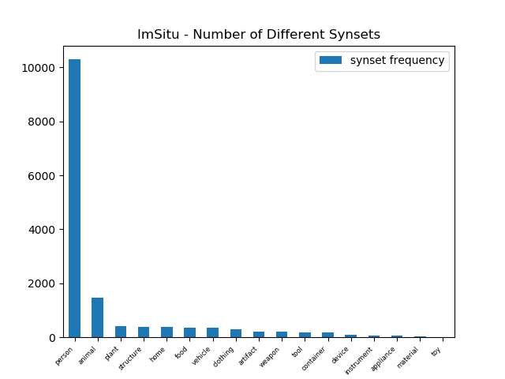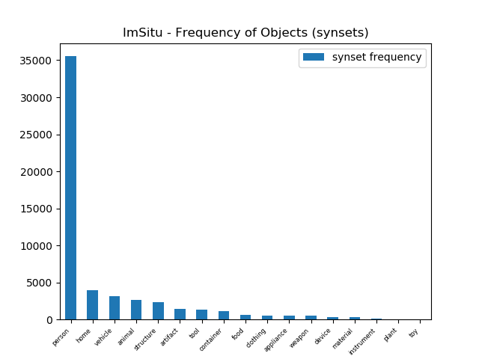

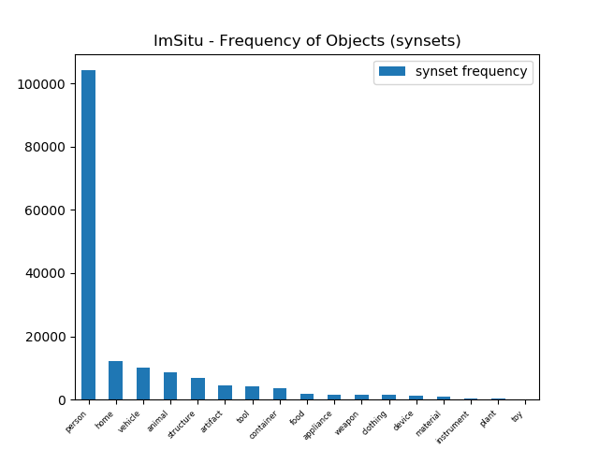

VISUAL GENOME

